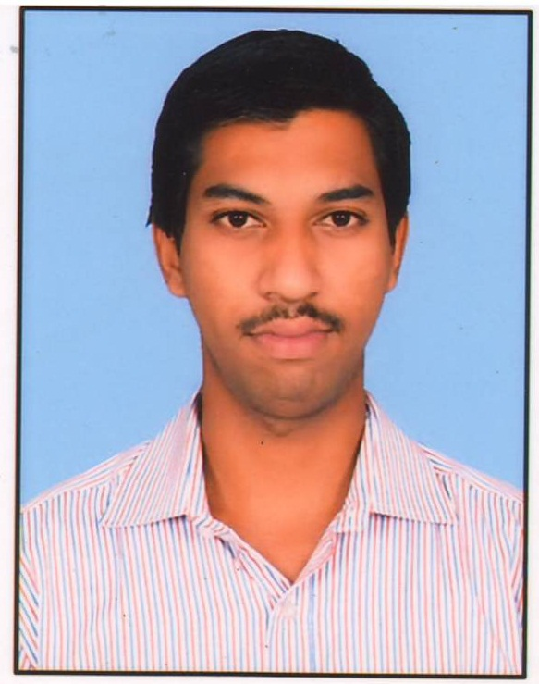
CURRUCULAM VITAE
ABHISHEK T R S
Shakthiman Poultry
Farm, Behind St Joseph School
Opp: TSP , Indira Nagar, T.B.Dam,
Hospet (TQ) Bellary (Dist)
Karnataka (State)
Mobile: +91-9611116741
E-mail: charlieabhishek96@gmail.com

Professional Profile

I would like to seek a progressive carrier which utilizes my skills , leadership skills and knowledge to the fullest in order to fulfill the requirement of the organization with an opportunity for the professional growth and excellence.

Areas Of Strengths:

- Smart Worker
- Team Worker
- Adaptable

Educational credential:

COURSE | BOARD | SCHOOL/COLLEGE | YEAR OF PASSING | PERCENTAGE
Secondary school leaving  certificate | Karnataka State Educational Examination Board | Saint Joseph  High School | 2011 | 82.72
Diploma in  Mechanical | Diploma Of Technical Board | T.M.A.E.S  Polytechnic | 2014 | 71.93
B.E in  Mechanical | Visveshvarayya Technological University, Belgaum | Sri Jagadguru Chandrashekaranatha Institute Of  Technology | 2017 | 67.73

Licenses & Certification:

Indian Union Driving License for LMV and MCWG, valid up to May’ 2034
Republic of India - Passport valid up to June’ 2027

Personal Information:

Date of Birth (Age) : October 22nd 1995
Marital Status : Bachelor
Language’s known : English,Hindi, Kannada and Telugu

(ABHISHEK T R S)

